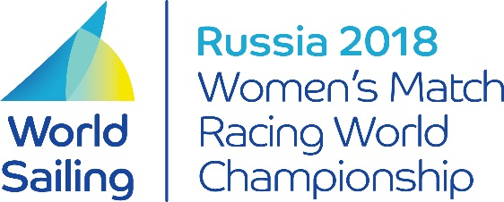
2018 Women’s Match Racing
World Championship
Øverst på formularen

INVITE REQUEST FORM

We apply for an invitation for the 2018 World Sailing Women’s Match Racing World Championship as per Notice of Race 5.

Skipper WS Sailor ID E-mail address

Summary of recent match racing experience

Signature Date

Please return the completed and signed form to the World Sailing Executive Office via email (matchracing@sailing.org)

